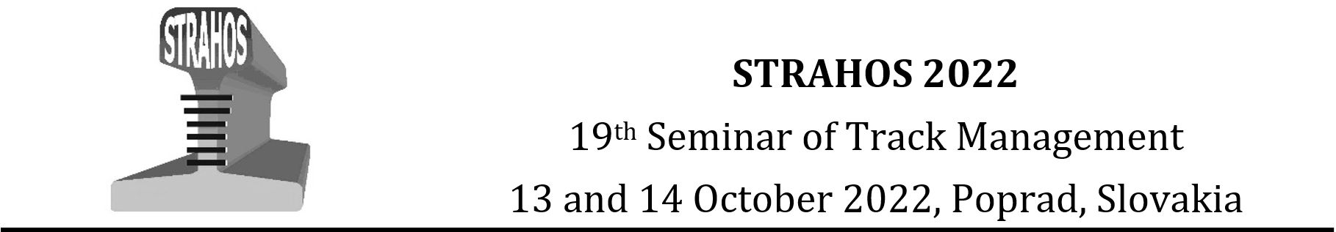
Workshop ’Research Activities of Young Researchers in Railways’

GUIDELINES FOR WRITING ABSTRACT OF PRESENTATION

For the WORKSHOP of The 19th seminar
of track managemet Strahos 2022

Name Surname, Name Surname, Name Surname, … *

* Author’s full postal address of affiliation including the country name.
Corresponding author’s e-mail address.

Abstract
The abstract should summarize the contents of the presentation in short terms, i.e. 150-250 words; justified between the margins and using the font/size specified below.

Keywords
Type your keywords here, separated by semicolons ;

Acknowledgment(s)
Authors wishing to acknowledge assistance or encouragement from colleagues, special work by technical staff or financial support from organizations should do so in an unnumbered Acknowledgments section immediately following the last numbered section of the paper.

This work was supported by the Grant No. 22120015. The project is co-financed by the Governments of Czechia, Hungary, Poland and Slovakia through Visegrad Grants from International Visegrad Fund. The mission of the fund is to advance ideas  for sustainable regional cooperation in Central Europe. | 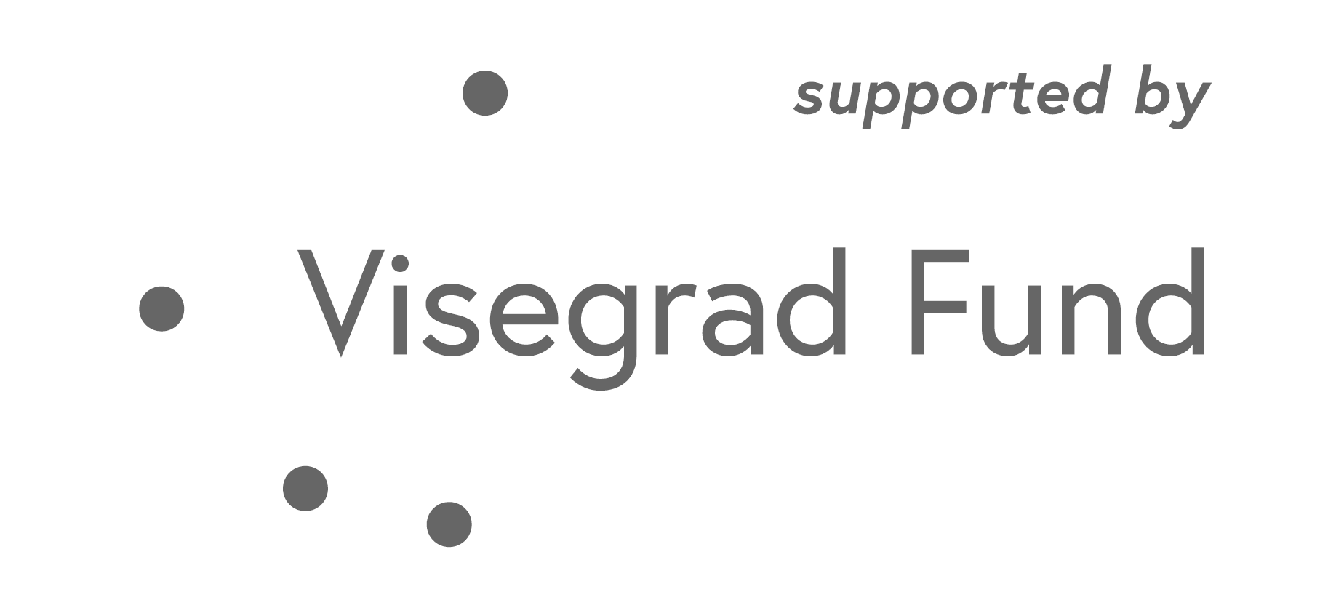

References
[1] SAMBROOK, J., RUSSELL, D. Molecular cloning: a laboratory manual. 3. ed. Cold Spring Harbor, NY: CSHL Press, 2001. ISBN 0879695773.
[2] GROSS, P. Railway track cracks identification. In: 9th International Railway Conference : proceedings. Vol. 2. Mechanical engineering in transport. London : London College of Transport, 2001. ISBN 80-7157- 524-0, p. 262-268.
[3] Transport - Wikipedia [online]. [cit. 2019-02-21]. Available on internet: https://en.wikipedia.org/wiki/Transport

